Disclosure for Jazz Band
From Many, One.
Teacher: Brandon Larsen
Email: brandon.larsen@jordandistrict.org
Website: herrimanbands.com (ALL calendar items and schedule on this website)
Phone: 801-567-8530 ext. 7201
Office Hours: I will usually be available for consultation and tutoring before and after school M-F, during MAP time, and during first lunch. If you need to meet with me, please send me an email or talk to me in person and we can set up an appointment. Email is the best way to contact me.
Purpose: We are dedicated to providing students with a high quality education and preparing them to thrive in a dynamic society as caring, creative, and responsible adults.
Class Description:
Students will learn to play a variety of music in a performing ensemble. We will cover the technical aspects of playing an instrument as well as some aspects of music theory, individual performance and history.
YOU WILL NEED:
- An instrument (If you need to rent an instrument from the school, please talk to me ASAP you will need to fill out an instrument rental form and pay an $80 district instrument rental fee)
- A pencil for marking the music and doing assignments
- To pay your class fees and get a uniform for performances (see class fees and uniform requirements later in this disclosure)
- To ALWAYS check the calendar for upcoming dates and events. Please note the calendar is a “live calendar” where dates may change or be added. Mr. Larsen will always give at very least 2 weeks notice for any change on the calendar. More on expectations on required dates to come in this disclosure.
Fees:
- $30 Class fee (helps to pay for clinicians and festival fees mainly, other equipment, and or special method books, etc.…)
- $50 District Participation Fee*
- $80 District Instrument Rental Fee** (Only for those who need to rent a school-owned instrument**)

Expectations:
- Be prepared. That means come to class with a working instrument, the music we are rehearsing, a pencil, and any other needed materials. It also means that you should have practiced the music enough on your own to have a successful rehearsal with the ensemble.
- Participate positively. We need every single member of the band playing his or her best every day. Do not sleep, read, or do work for other classes in band. The time we have to rehearse is limited, and we need to make the most of it. It is also important to be positive and have a good attitude. I will not tolerate negative comments directed toward any member of the group.
- Be engaged in the rehearsal. At all times you should be trying to gather information and apply it to your individual performance and take mental and physical notes of what the teacher expects of you. This means no talking while the conductor is rehearsing – this includes while the teacher is working with another section in the band. Glean what you can from all instruction.
- No gum, food, or drink. Instruments and music are expensive, and the music room is used by several different groups. In order to keep the room clean and the instruments safe from accidental spills, please do not eat, drink, or chew gum in class. You may have a water bottle if it has a lid that closes tightly.
- Take care of school property. Everyone uses school property and we want to keep it as nice as possible. School instruments, chairs, stands, etc. are expensive to replace. Please treat them as well as possible and keep our school as nice as it is now. If possible, try to make it better. Stands need to go back to the stand rack, chairs back stacked back on each other in designated area, no higher than 8 per stack. No food/drink in practice rooms (except water), and when you leave stack chairs and stands in the corner, turn lights off and close the door.
- Be respectful of others’ property. Do not use anyone else’s property without their permission. Be especially careful around other people’s instruments.
- Electronic devices will only be allowed out if being used for tuning purposes. Turn devices to airplane mode, turn Wi-Fi off, and only use for tuning. If I or another witness see you using a phone, mp3 player, iPod, camera, gaming device, or any other type of personal electronic device during class not for tuning purposes, I will confiscate it until the end of the school day. See the school/district policy on electronic devices.
- Dress Appropriately: Follow the school dress code, or I will ask you to go to the office.

Positive Consequences:
- You will play better.
- You will have the satisfaction of knowing you did the right thing.
- The class will be more enjoyable for everyone.
Negative Consequences:
- Verbal warning.
- Discipline comment in Skyward and parent contact.
- Referral to the school administration.

Grading:
Grades will be based on participation, playing tests, concert attendance, and assignments.
Grading Scale:
A = 100-93% B = 86-83% C = 76-73% D = 63-66%
A- = 92-90% B- = 82-80% C- = 72-70% D- = 62-60%
B+ = 89-87% C+ = 79-77% D+ = 67-69% F = 59 and below

Participation: Participation points will be awarded for meeting the class expectations and contributing positively to the group. Students can earn up to 20 points a day by:
- Coming to class on time
- Staying through the entire class period
- Having all the music and a pencil
- Having your instrument
- Cleaning up completely at the end of class
- Playing with the group at appropriate times
- Having good rehearsal etiquette (not talking when the director is rehearsing, playing with the group, making notes in the music, not texting or playing games on your phone, etc.)
If students lose participation points from an excused absence, they can make up the full points by practicing at home for one hour, completing a practice log and turning it in within one week of the absence. Half credit will be given for practice logs that are turned in after one week. If students lose participation points for not being prepared or by detracting from the rehearsal in some way, they cannot make up the points.
Playing Tests: To hold students accountable for things we learn in class and to give students some one-on-one instruction, we will have playing tests on the music and on technical skills (scales, exercises…etc.) several times throughout each term. Students will be given at least a week to prepare before the test.
Assignments and projects: While this is a performance-based class, we will also do some listening, transcription projects, artist reports, combo projects, music/jazz theory, and history assignments periodically. These assignments will generally be done in class, although there will be a few that need to be done outside of class – particularly the transcription projects and artist reports (rubrics will come out during the year about these).
Concert Reports: Students will need to attend a high school level concert or higher that has their instrument performing in the ensemble they see. They will then need to write a 1 paged, double-spaced, 12 pt. font reflection report on the concert they attended. Concert reports will be due 1 week before the last day of each term for full credit. Any late reports will receive half credit. A rubric will come out for this at a later time.
Sectionals:
Sectionals will be held and will be a part of the student’s grade. Each sectional is worth 25 points. Sectionals in concert band will be rehearsed by leaders of the sections (section leader) and Mr. Larsen may be available to help at times. More information about this will come in class. These sectionals will be required and a part of your grade. For the duration of marching band season (August-Nov. 1) these sectionals will be held only twice a month (every other week) and need to be equivalent of 1 hour at each sitting. Once marching band is done, sectionals will be required once a week for an equivalent of 1 hour each week. With this year’s “MAP” period, you may plan a sectional with your section leader, but everyone in the section would need to be in attendance. If they are failing a different class they cannot be expected to make it to that MAP period and you will need to reschedule. 2 MAP periods will suffice to equal 1 sectional if you choose to use that time. I rather you use the hour on Friday from 7am-8am for sectionals that may be the best time (after marching season). I take these sectionals VERY seriously and these need to happen in order for our band to continue to get better. If you are in multiple ensembles, you will still need to do a weekly sectional for multiple ensembles. Again, during marching band it is every other week.

Make-up Work: If students have an excused absence and it is a planned absence I still expect all work in at the time the due date is given. However, there are times when students are not planning on being absent when it is out of their hands. When this happens and a student has an excused absence, and an assignment is due they will be given 5 school days or one week after returning to school to turn in any missed work for full credit. After that time the assignment becomes late and will only receive half credit. If you have trouble completing the work, contact me via email or see me before or after class on the day of your return. In cases of extended illness, it is the student‘s responsibility to make arrangements with the instructor if more time is needed.
Late Work: Late assignments can be turned in for half credit upon conditions if you had an excused absence. If absences are not excused you may receive additional work to make up any late work.
Concert Attendance: As this is a performing class, students must be to all concerts throughout the school year.
If a conflict comes up and you will not be able to attend a concert, please tell me as soon as possible. In order to be able to make up the full points, you need to turn in a performance excusal form two weeks in advance. You can make up partial points if you turn in the form a week in advance. If you do not turn in the form at least one week in advance, you will NOT be able to make up the points unless you have an extreme illness, a death in the family, or an unavoidable emergency. In that case, please email me or turn in the excusal form on the first class after the concert. Students who do not come to a concert and do not have an excuse that fits into one of those categories and/or do not turn in the excusal form within a week of the concert will not be allowed to make up the points. Students WILL NOT be able to make up a performance missed due to a vacation. Students who have told me about the conflict in advance can do an equivalent performance in place of the concert. You will need to talk to me about what I expect you to do to make up the points.
Extra Credit: There will be opportunities for extra credit, Mr. Larsen will explain in class. Or you may speak to him about opportunities for extra credit.
Schedule: ALL dates of extra rehearsals, concerts, and performances are located on the band calendar found at herrimanbands.com. PLEASE NOTE that this is a “live calendar” and dates, times, location may be changed, modified, or added. Mr. Larsen will always give at least 2 week’s notice for any change. Please look ahead in the calendar and plan accordingly.

To add the Herriman bands calendar to your own Google calendar, go to the herrimanbands.com website, click on “calendars,” click on “HHS Band,” go to the bottom right corner of the calendar and click on the icon that looks like this:
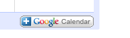
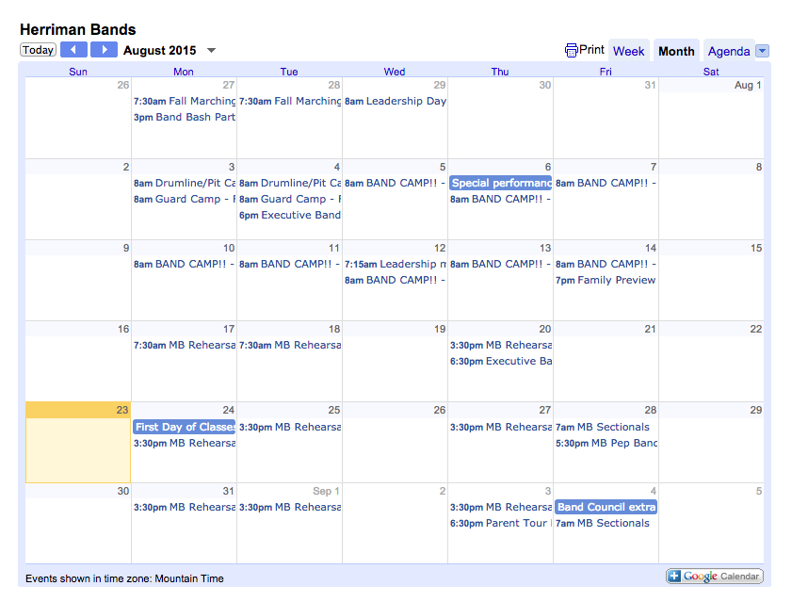
Please sync these dates to your personal devices.
For a quick tutorial on how to sync the Herriman bands calendar to your mobile devices watch this link:
https://youtu.be/f1Mi_DAHN4s

Uniforms: Will be discussed in class. Depending on what students and Mr. Larsen discusses, there may be a fee associated.
Electronic information and communication resources
Charms
The band program will be using an online database to catalog attendance, receipts, music, communications and many, many more things. If you are not already signed up for Charms you will need to do so ASAP.
To sign in you need to follow the steps below.
1 – Go to charmsoffice.com
2 – Scroll over “Enter” in the upper right corner and click on Parent/Student/Helper
3 – Type “HerrimanBand” (no spaces, not case sensitive)
4 – Enter your JSD student number when asked for your ID
5 – Click on “Update personal info” in the bottom left corner
6 – Fill in all blocks
7 – Click “Add Adult” and enter info for all guardians
This is the first assignment for this class. You will have until Friday, September 4 to complete this assignment. Everyone must log in to Charms and verify that their information is correct.
Please read, initial, and sign this page, then return it to Mr. Larsen by Aug. 29, 2016
Acknowledgement of Band Disclosure Policies:
- I understand and agree to the grading system in band, as outlined in the disclosure.
Student Initials: _____ Parent Initials: _____
- I know that I can make up participation points by practicing for an hour outside of class and turning in a practice log. The practice log must be turned in within one week of the absence for full credit.
Student Initials: _____ Parent Initials: _____
- I understand that any late work I turn in will only receive half credit.
Student Initials: _____ Parent Initials: _____
- I agree to attend all of the performances and rehearsals on the band calendar found at herrimanbands.com.
Student Initials: _____ Parent Initials: _____
- I understand that some rehearsals and performances may come up during the year that are not on the disclosure, and that those may also be counted toward my grade. I agree to attend those performances and rehearsals as well, as long as Mr. Larsen gives me at least two weeks’ notice.
Student Initials: _____ Parent Initials: _____
- I understand that if I have to miss a performance, I need to turn in a performance excusal form at least two weeks in advance to be able to make up the full points, or one week in advance for partial credit.
Student Initials: _____ Parent Initials: _____
- If I miss a concert due to an extreme illness or emergency (as outlined in the disclosure), I will turn in a performance excusal form NO LATER than one week after the concert if I want to make up the points.
Student Initials: _____ Parent Initials: _____
- I understand that if I miss a required performance due to a vacation, I will not be able to make up those points.
Student Initials: _____ Parent Initials: _____
- I know that I am expected to be in the appropriate concert black outfit (as described in the disclosure) for all formal performances, and I understand I am responsible to get my own concert black.
Student Initials: _____ Parent Initials: _____
- Media Release: I give the Herriman High School Band Department to take and post pictures of my child on social media, the band website and in other forms of band archival.
Student Initials_______ Parent Intitials_______
I have read the disclosure in its entirety and I understand the class policies. I agree to abide by them.
Student’s Name (Please print): ______________________________________________________
Student’s Signature: ______________________________________________________________
Parent or Guardian’s Signature: _____________________________________________________
Administrator’s Approval: __________________________________________________________

